|  |
| --- |
| Group-G17 OnlineBookstore  ONLINE BOOKSTORE  A MINI PROJECT REPORT  *Submitted by*  Group: G15  HARSHDEEP SINGH (2410991322)  HARSHITA(2410991336)  HARWINDER KAUR(2410991340)  *in partial fulfillment for the award of the degree of*  BACHELEOROFENGINEERING  *in*  CSE-AI    CHITKARA UNIVERSITY  CHANDIGARH-PATIALANATIONAL HIGHWAY  RAJPURA(PATIALA) PUNJAB-140401(INDIA)  September,2024  Front End Engineering-1 24CSE0102  24CSE0102 |
| Group-G17 ABSTRACT  A random code generator is a critical tool used in a wide variety of applications, ranging from secure user authentication and financial transactions to promotional campaigns, software licensing, and unique user identifiers. This system automates the generation of secure, unpredictable, and unique codes tailored to specific requirements, such as length, character set, and formatting. The key strength of the generator lies in its ability to produce random codes that are resistant to predictability and duplication, thereby ensuring high levels of security, particularly for sensitive tasks like generating one-time passwords (OTPs), voucher codes, and session identifiers. By utilizing advanced algorithms, the generator can ensure true randomness, reducing the risk of brute force attacks and unauthorized access.  The generator is highly scalable, designed to handle large volumes of code generation efficiently, which is particularly important for large-scale promotional events, e-commerce platforms, or any application where a vast number of unique codes must be produced in a short period. Moreover, its customizable nature allows businesses to define the exact format of the codes, such as alphanumeric combinations, special characters, or specific patterns, making it suitable for a broad range of use cases. The system also supports seamless integration with existing technologies, such as databases, customer relationship management (CRM) systems, and e-commerce platforms, ensuring smooth operations and centralized management of generated codes. The generator is highly scalable, designed to handle large volumes of code generation efficiently, which is particularly important for large-scale promotional events, e-commerce platforms, or any application where a vast number of unique codes must be produced in a short period. Moreover, its customizable nature allows businesses to define the exact format of the codes, such as alphanumeric combinations, special characters, or specific patterns, making it suitable for a broad range of use cases. The system also supports seamless integration with existing technologies, such as databases, customer relationship management (CRM) systems, and e-commerce platforms, ensuring smooth operations and centralized management of generated codes. Additional features such as real-time validation, code tracking, expiration management, and automated error handling make the random code generator a reliable tool for businesses. These features not only improve operational efficiency but also ensure that generated codes remain valid, secure, and usable throughout their lifecycle. By preventing duplication and misuse, the system enhances the user experience, fostering greater trust and confidence in the services that rely on these codes. This paper examines the design, functionality, and implementation of random code generators, emphasizing their importance in boosting security, improving operational workflows, and supporting scalable business growth in today’s increasingly digital world.  Front End Engineering-1 24CSE0102 |

|  |  |  |  |  |  |  |  |  |  |  |  |  |  |  |  |  |  |  |  |  |  |  |  |  |  |  |  |  |  |  |
| --- | --- | --- | --- | --- | --- | --- | --- | --- | --- | --- | --- | --- | --- | --- | --- | --- | --- | --- | --- | --- | --- | --- | --- | --- | --- | --- | --- | --- | --- | --- |
| Group-G15 RandomCodeGenerator  TABLEOFCONTENTS   |  |  |  | | --- | --- | --- | | Sr.no | Section | Page no. | | 1 | Introduction | 1-2 | | 2 | Problem Statement | 2-3 | | 3 | Technical Details | 3-4 | | 4 | Key  Features | 4-5 | | 5 | Project  Advantages | 5-6 | | 6 | Project Highlights | 6-10 | | 7 | Bonus feature | 10-1 | | 8 | Conclusion | 11-12 | | 9 | References/ link used | 12 |   Front End Engineering-1 24CSE0102 |
| Group-G15 RandomCodeGenerator  1.Introduction  Overview  A Random Quote Generator is a creative and interactive tooldesigned to provide users with randomly selected quotes for inspiration, motivation, or entertainment. It is often implemented as a web-based application, mobile app, or desktop program, with features that make it both functional and engaging. These generators draw from a curated collection of quotes, which may be stored locally or fetched dynamically using APIs, ensuring users always encounter fresh and diverse content.  At its core, the random quote generator consists of three main components: the quote database, the randomization logic, and the user interface. The quote database can be static, containing hardcoded quotes within the application, or dynamic, using third-party APIs to fetch quotes in real-time. The randomization logic ensures that each quote is selected unpredictably, creating an element ofsurprise. Advanced implementations might incorporate algorithms to avoid repetitionuntil all quotes have been displayed. The user interface plays a crucial role in enhancing user experience, often featuring a clean and intuitive design with buttons to generate new quotes, share quoteson social media, or save favourites.  These tools are highly versatile and can cater to different themes or audiences. For example, some generators focus on motivational quotes for personalgrowth, while others emphasize humour, famous historical quotes, or literary excerpts. Customization options, such as filtering quotes by category, author, or mood, make the generator more appealing to a broader audience. They may also include features like scheduling daily quotes, enabling users to receive their dose of inspiration without needing to open the app actively.  From a development perspective, building a random quote generator is an excellent project for learning programming concepts. It introduces beginners to the basics of arrays, functions, and randomization while also providing opportunities to work with APIs, databases, and user interface design. Advanced developers can use frameworks like React, Angular, or Flutter to add more complex functionalities, such as animations, user authentication, or offline capabilities.  In practice, random quote generators have found applications in various domains. They are popular on websites and apps like Brainy Quote or Goodreads, offering users quick inspiration. They are also used in educationaltools, showcasing famous speeches or proverbs to spark curiosity and learning. Moreover, they serve as creative outlets for developers, combining simplicity with the potential for endless innovation.  In conclusion, a random quote generator is more than just a toolfor displaying quotes; it is a source of positivity and creativity for users and a valuable learning opportunity for developers. Its simplicity and adaptability make it a widely appreciated project, whether for  Front End Engineering-1 24CSE0102 |

|  |  |
| --- | --- |
| Group-G15 | RandomCodeGenerator |
| personal use, professional application, or educational purposes.  Front End Engineering-1 | 24CSE0102 |

|  |
| --- |
| Group-G15 RandomCodeGenerator  2. Problem Statement   1. Repetition or Collisions:   When generating large volumes of codes, the likelihood of duplicates increases, especially if randomness algorithms are not robust. Duplicate codes can cause errors, such as invalid authentication attempts, duplicate redemptions of coupons, or conflicts in database systems.  This undermines the reliability and usability of the codes.   1. Insufficient Security:   Predictable or insufficiently random codes can lead to potential misuse. For example, in the case ofpasswords, discount codes, or session keys, attackers might exploit patterns to guess valid codes. This exposes systems to security vulnerabilities, potentially resulting in data breaches, financial losses, or reputationaldamage.   1. Performance Bottlenecks in Large-Scale Generation:   Generating and validating millions of unique codes in real time can strain system resources. This is particularly challenging in high-demand scenarios, such as flash sales or mass promotions, where speed and reliability are critical. Poor performance can result in system crashes, increased latency, and user dissatisfaction.   1. Inefficient Management of Generated Codes:   Many systems do not have effective mechanisms for storing, tracking, or validating generated codes. For instance:   * + Ensuring that previously generated codes are not reissued requires robust databases and checks, which are often poorly implemented.   + Tracking the usage and status of codes (e.g., redeemed, expired) can be cumbersome without a proper management system.  1. Integrationwith Existing Systems:   Random code generators often need to integrate seamlessly with other systems, such as APIs, databases, or front-end interfaces. Incompatibility with existing workflows can result in additional development overhead and reduced operationalefficiency.  Front End Engineering-1 24CSE0102 |

|  |
| --- |
| Group-G15 RandomCodeGenerator   1. Technical Details    1. Technologies Used       1. HTML:   HTML (Hyper Text Markup Language) is the standard language used to create and design web pages.  It structures content on the web using a system of elements and tags to format text, images, links, videos, and other multimedia elements.  HTML is often used with CSS (Cascading Style Sheets) for styling and JavaScript for interactivity, but it serves as the backbone for any web page or web application.   * + 1. CSS:   CSS (Cascading Style Sheets) is a language designed to simplify the process of making web page presentable.  CSS provides developers and designers with powerful control over the presentation of HTML elements.  CSS is a powerful toolfor creating visually engaging and responsive web designs, allowing developers to controlthe look and feel of their websites comprehensively.   * + 1. JAVASCRIPT:   JavaScript is a versatile, high-level programming language primarily used to create interactive and dynamic content on websites. It runs on the client side in web browsers, enabling features like animations, form validations, and responsive interfaces. With frameworks and libraries like React, Angular, and Node.js, JavaScript extends its capabilities to server-side development, mobile applications, and even game development. Its ease of use, compatibility with HTML/CSS, and vast ecosystem make it a cornerstone of modern web development.  Front End Engineering-1 24CSE0102 |

|  |
| --- |
| Group-G15 RandomCodeGenerator  4. Key Feature   1. Uniqueness:   Every generated code must be distinct to prevent conflicts. For instance, in applications like coupons, voucher systems, or unique identifiers, duplicate codes can cause errors such as multiple redemptions of the same voucher or incorrect user identification. A reliable generator ensures that no code is repeated, even in high-volume scenarios.   1. Randomness:   The generator should produce codes that are not only unique but also unpredictable. True randomness is vital for security purposes, such as in password generationor cryptographic keys.  Predictable patterns can be exploited, making the system vulnerable to attacks.   1. Scalability:   The system must efficiently handle the generation of thousands or even millions of codes without performance degradation. This is especially critical in scenarios like large-scale marketing campaigns, where a high volume of codes must be produced and distributed quickly.   1. Validation:   A robust generator verifies that every code meets the specified criteria (length, format, character set) and ensures that no duplicates exist. This validation can occur both during generation and before assigning the code to a user or system.   1. Security:   Security is essential for use cases involving sensitive data or financial transactions. Advanced random code generators utilize cryptographic algorithms to generate secure codes that cannot be easily guessed or reverse-engineered. For instance, using UUIDs (Universally Unique Identifiers) or hash-based methods ensures a higher level of security compared to simple random number generation.  Front End Engineering-1 24CSE0102 |



|  |
| --- |
| Group-G15 RandomCodeGenerator  5. Project Advantages   1. Enhanced Security:   By generating random, unpredictable codes, the system minimizes risks associated with code duplication, brute force attacks, or predictability. This is particularly advantageous for secure applications like OTPs, API keys, or password generation.   1. Improved Efficiency:   Automating the process of generating codes eliminates manual errors and speeds up operations. Large volumes of codes can be created and managed in seconds, making it ideal for high-demand use cases such as marketing campaigns or software licensing.  3.Flexibility and Customization:  A random code generator can be tailored to meet specific requirements, such as generating codes with predefined lengths, formats, or character sets. This flexibility supports diverse applications across industries like e-commerce, gaming, or enterprise software.  4.Cost Savings:  Automating code generation reduces reliance on manual processes, lowering labor costs and minimizing human error. It also prevents losses caused by issues like duplicate or misused codes, saving businesses from financial and reputational damage.  5.Scalability:  The system can handle increasing demands efficiently, whether it's generating a few codes for a small team or millions for a global promotion. This scalability ensures the solution grows alongside the business.  6.Reliability:  A well-designed generator ensures code uniqueness, reducing conflicts and improving the reliability of processes like authentication, discount redemption, or product registration.  7.Better User Experience:  For end-users, random code generators enhance trust and convenience. Secure OTPs or easily redeemable promo codes create a smooth and enjoyable user journey, improving customer satisfaction.  8.Comphrensive Management:  Features such as code tracking, expiration management, and usage monitoring make it easier to manage large sets of codes, ensuring proper utilization and avoiding misuse.  Front End Engineering-1 24CSE0102 |

Group

-

G15

Random

Code

Generator

6

.

Project

Highlights

The

following

images

are

some

of

the

project

highlights:

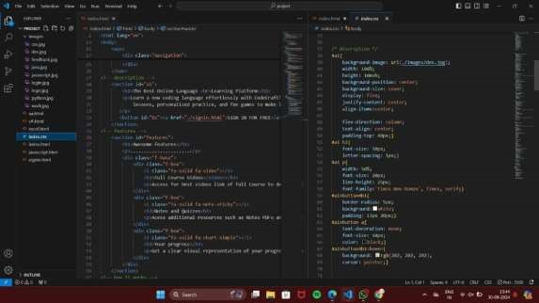

Group

-

G15

Random

Code

Generator

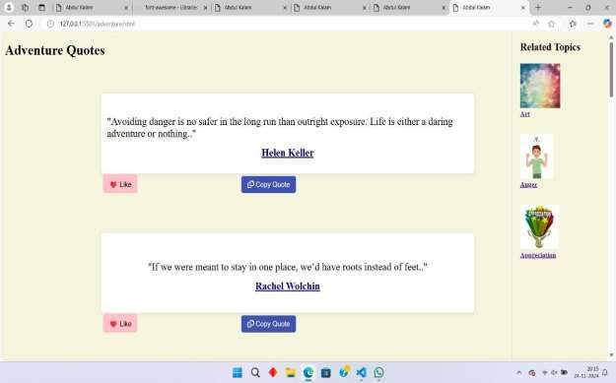

Group

-

G15

Random

Code

Generator

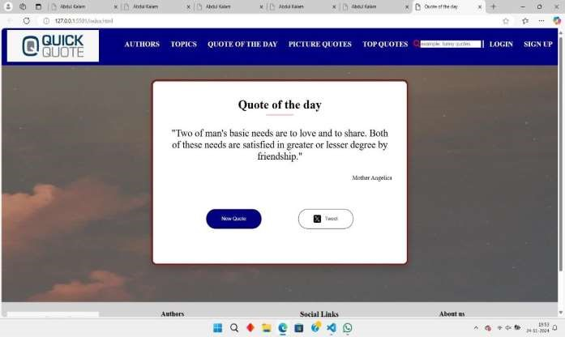

|  |
| --- |
| Group-G15 RandomCodeGenerator  7. Bonus Features  •Allow users to share quotes on social media platforms.  •Randomized Backgrounds: Change the background image or color dynamically each time a quote is generated to create a visually stimulating experience..  •Add animations to enhance the quote transition.  •Quote of the Day: Highlight a specific "quote of the day" that providing a focal point for daily inspiration. |

|  |  |  |
| --- | --- | --- |
|  | Group-G15 RandomCodeGenerator | |
|  | Conclusion  In conclusion, a random code generator is a highly valuable and versatile toolthat addresses several key challenges across various industries, offering tremendous benefits in terms of security, efficiency, scalability, and flexibility. By automating the process of generating unique and unpredictable codes, it significantly reduces the risks associated with human error, duplication, and predictability. This is particularly crucial in applications such as user authentication, secure financial transactions, promotional campaigns, software licensing, and even data anonymization, where security and accuracyare paramount. With customizable formats, such as alphanumeric, numeric, or special character combinations, the generator can cater to specific business needs, ensuring that the generated codes align with required standards.  The generator's ability to handle high-volume demands and produce codes in real-time makes it ideal for scenarios such as large-scale promotions or large databases of unique user identifiers, where efficiency is a priority. Furthermore, its seamless integrationwith existing systems like CRMs, databases, and e-commerce platforms enables it to fit into the broader digital ecosystem, allowing for better management and tracking of codes. Features like code expiration, usage monitoring, and real-time validation enhance the user experience by ensuring that codes are valid, secure, and not used more than once, helping to prevent misuse.  From a security standpoint, random code generators utilizing advanced cryptographic algorithms ensure that codes are not easily guessable, safeguarding sensitive data and reducing vulnerabilities. This aspect is essential in industries that deal with high-stakes transactions, such as banking, healthcare, and online services. Additionally, automated generation reduces costs associated with manual code creation and monitoring, while also minimizing human error and saving valuable time. Scalability is another key advantage, as the system can efficiently grow to accommodate increasing volumes of code generation without compromising performance or security, making it a future-proofsolution for businesses of all sizes.  Ultimately, the random code generator not only optimizes operationalworkflows but also strengthens customer trust by providing secure, reliable, and easily accessible codes for a range of purposes. By offering a robust, cost-effective, and flexible solution, it enables businesses to stay competitive in an increasingly digital world, meeting evolving demands for securityand efficiency in code generation. As the need for secure, unique identifiers continues to grow in the digital landscape, the random code generator stands as a crucial tool in ensuring the integrity and smooth functioning of systems across industries. | |
|  | Front End Engineering-1 | 24CSE0102 |

8.

|  |
| --- |
| Group-G15 RandomCodeGenerator  9.References/Links Used  References used by us to solve the problems while creating the address book:   1. Twitter Link: [https://twitter.com/intent/tweet?text=](https://twitter.com/intent/tweet?text) 2. API Link: <http://api.quotable.io/random> 3. Font Awesome Link: <https://cdnjs.cloudflare.com/ajax/libs/font-awesome/6.7.1/css/all.min.css>   Front End Engineering-1 24CSE0102 |